513 Project Checkin & Demo

Sunsmart

November 19, 2017

Alex Brooks, Kyle Kuan, Stephanie Zawada

**Clone Repository Link (Source Code):** <https://github.com/fnrj/ninjaSmartServerCode/>

**Website Document with Streaming Data:**

513checkinanddemo_brooks.kuan.zawada

|_bin

|_models

|_node_modules

**|_public**

|_res

|_stylesheets

|_about.html

|_contact.html

|_index.html

|_login.html

**|_mapscript.js**

**|_postdata.js**

|_products.html

|_script.js

**|_style.css**

**|_sunsmart.html**

**|_uvchart.js**

|_routes

|_views

|_513 Project Checkin_Brooks.Kuan.Zawada.docx

|_app.js

|_db.js

|_package.json

|_README.md

To access the streaming webpage, use the “sunsmart.html” page found in the directory path of the main folder, “513checkinanddemo_brooks.kuan.zawada”, outlined above. From this page, the bolded files in .css and .js are sourced and used for visualization and functionality as shown in the video (link below).

**Video Demonstration (Playlist Link):** <https://www.youtube.com/playlist?list=PLXT_uOMK9SVaokaWo4_2lLbcZQ9jfcfpX>

**Endpoint Documentation:**

/devices/register is used to add a device, i.e. POST, with the user email and device ID. It returns an API key and should be associated with photon access.

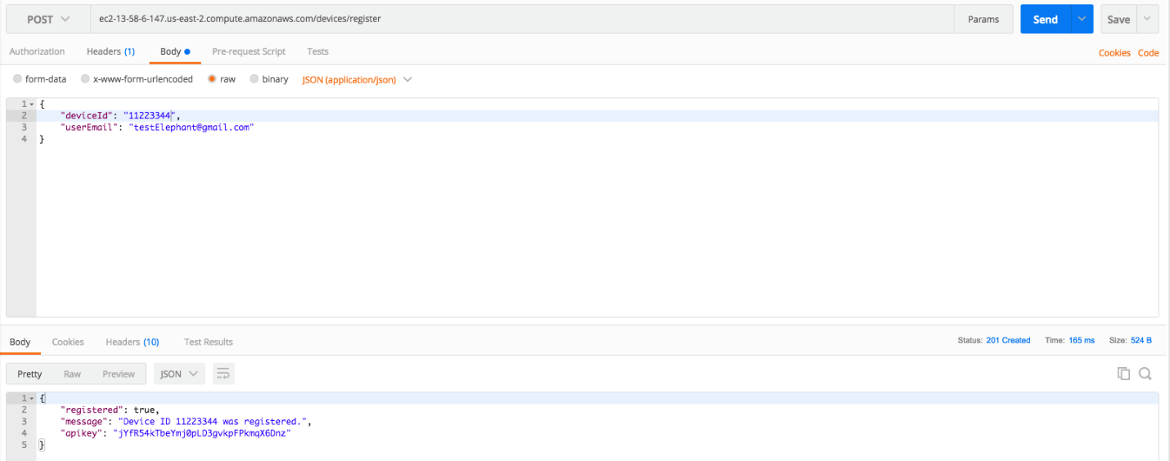

/devices/status can support GET, PUT, and DELETE requests.

A GET request will return JSON data using a valid email.

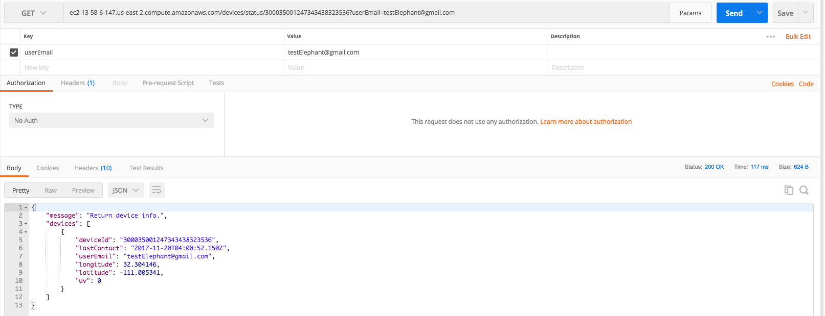

A PUT request is for the photon to update coordinates and UV with its device ID and API key.

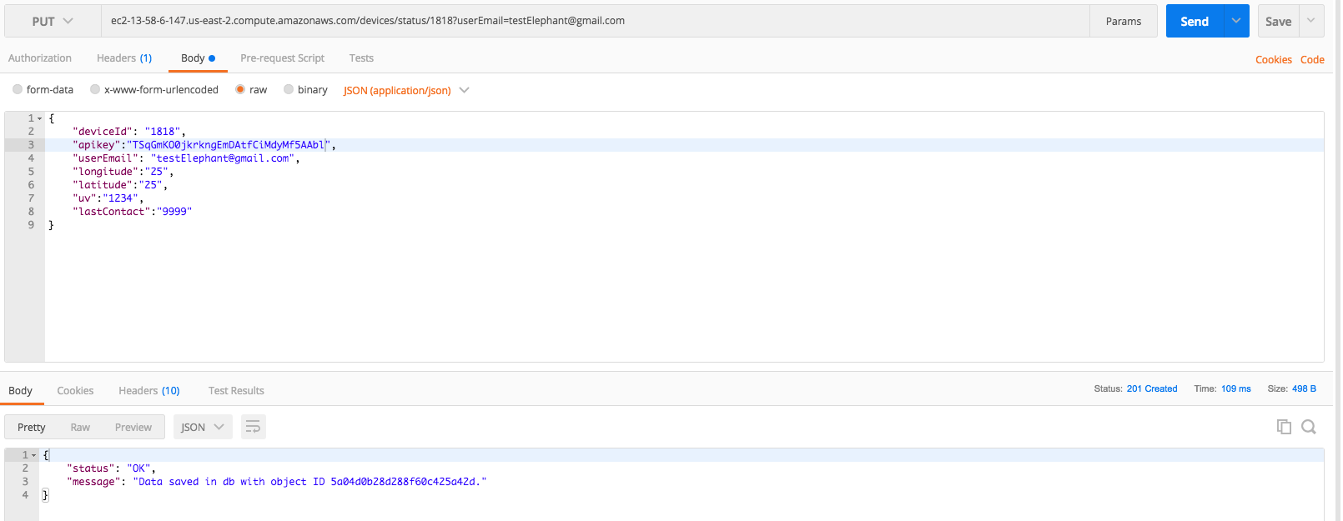

A DELETE request will delete specific IDs and data with a valid user email and device ID.

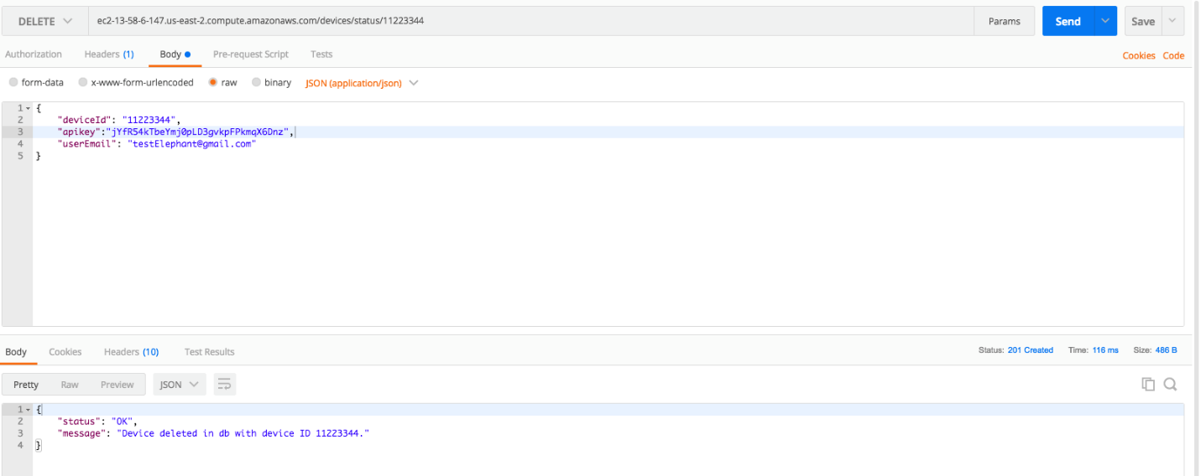

GET has an extra parameter, all, which can return all devices associated with the user.

https://ssl.gstatic.com/ui/v1/icons/mail/images/cleardot.gif

